Tweet Classification Using LSTM and   
Bi-LSTM Models

**Course:** CSC4093 – Neural Networks and Deep Learning

**Name:** K.K.M.K. Mewanga

**Reg No:** S/19/832

**Tweet Classification Using LSTM and Bi-LSTM Models**

**Course:** CSC4093 – Neural Networks and Deep Learning

**Name:** K.K.M.K. Mewanga

**Reg No:** S/19/832

## **Introduction-:**

As social media has grown in popularity, sites like Twitter have become essential channels for people to share their personal stories, including those pertaining to health issues. Medical research and disease surveillance are two public health initiatives that can benefit from automatically determining whether a tweet addresses a personal health concern. The project's goal is to create two deep learning models such as LSTM and Bi-LSTM that can distinguish between tweets that discuss personal health issues and those that don't. By looking at metrics like accuracy and loss, the main goal is to assess and contrast how well these models perform on this binary classification task.

## **Overview of the dataset-:**

This dataset consists of a set of tweets that have been labelled to show whether or not they are related to individual health experiences.

Two CSV files contain the data:

**phm_train.csv** with 9,991 labeled tweets used for training the models

**phm_test.csv**: This file includes 3,331 labelled tweets used for testing.  
  
The following columns are present in every entry in these files:

• *tweet_id*: A special number assigned to every tweet.   
• *label:* A binary indicator (0 or 1) that indicates whether a personal health mention is present.   
*• tweet*: The tweet's textual content.

To get ready for input into machine learning models, the tweets have undergone preprocessing procedures like text cleaning, tokenization, and padding. Following processing, these sequences are used in Long Short-Term Memory (LSTM) and Bidirectional LSTM (Bi-LSTM) models, which use embedding layers to identify and anticipate patterns associated with mentions of personal health.

.

## **Overview of the Model-:**

In order to capture semantic meaning right away, both models start with an embedding layer that converts each word into a 32-dimensional trainable vector. The LSTM model processes tweets sequentially from beginning to end using a single 64-unit unidirectional LSTM layer. By using a bidirectional LSTM, which has 64 units in each direction, the Bi-LSTM model, on the other hand, reads the tweets both forward and backwards, enhancing its comprehension by incorporating context from both words that come before and after. Both models then classify tweets as either personal health mentions (1) or not (0) using a Dense output layer with a sigmoid activation. The Adam optimizer, binary cross-entropy loss, and accuracy as the evaluation metric were used for training both models.

## **Performance Comparison and Discussion**

## **Model output summary**

* LSTM

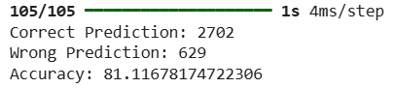

* Bi-LSTM

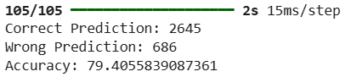

**Interpretation**

The LSTM model achieved 81.12% test accuracy, correctly classifying 2,702 out of 3,331 tweets and misclassifying 629. By contrast, the Bi-LSTM model achieved a slightly lower test accuracy of 79.41% with 2,645 correct predictions and 686 errors. The Bi-LSTM may have performed better during training, but it appears to have overfitted the training data based on its lower accuracy on the test set. For this classification task, however, the standard LSTM proved to be the more dependable option due to its superior generalization to unseen tweets.

## **Accuracy and loss plots**

* LSTM

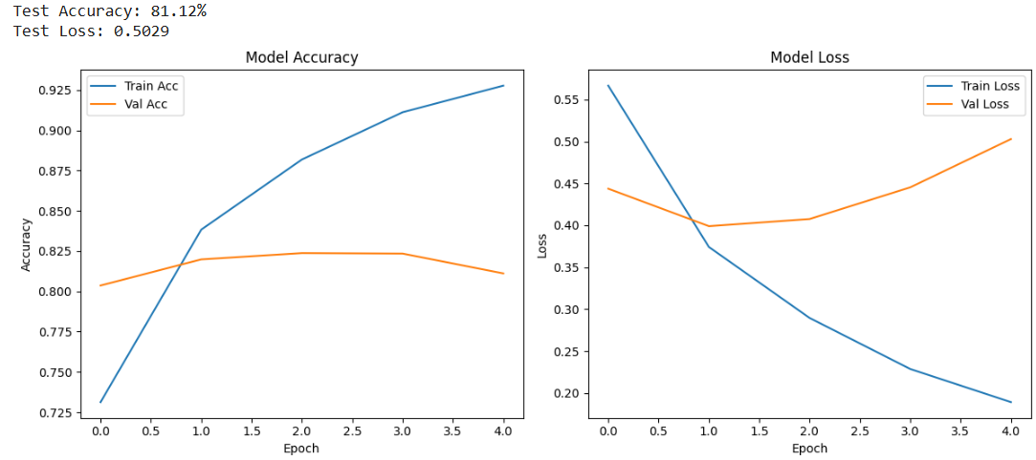

* Bi-LSTM

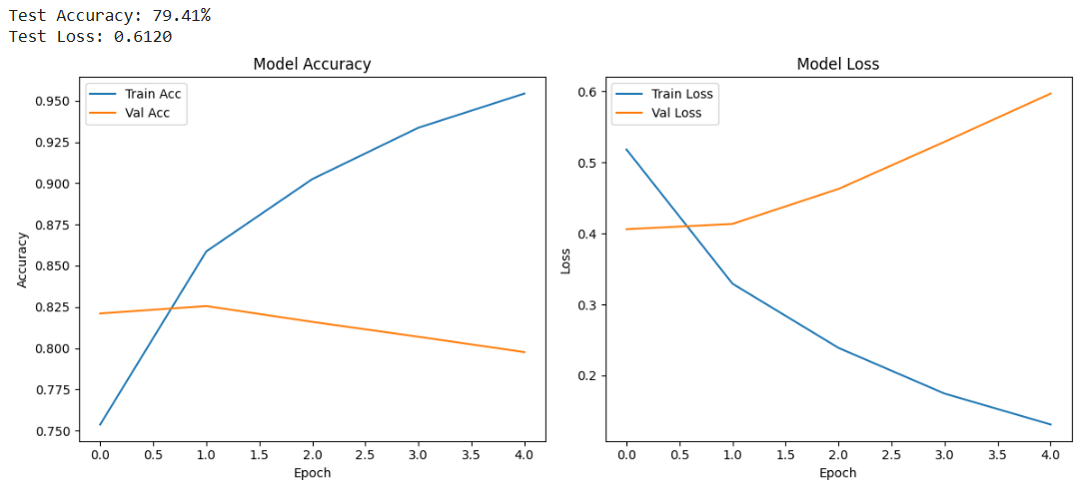

**Interpretation**

With a test accuracy of 81.12% and a loss of 0.5029, the LSTM model outperformed the Bi-LSTM, which showed superior generalization. The Bi-LSTM, on the other hand, managed 79.41% accuracy and a loss of 0.6120. Both models learnt well during training by the fourth epoch, accuracy had increased from about 74% to over 92–95%. However, their validation behavior was different as the Bi-LSTM's validation loss spiked and accuracy decreased after the first epoch, which are typical indications of overfitting. On the other hand, the LSTM showed a slight increase in validation loss and a consistent validation accuracy, suggesting that it generalizes to new data with greater reliability. For this tweet classification task, the simpler LSTM is the more reliable and robust option due to its consistency and stability.

**Conclusion**

This study used a real-world Twitter dataset to test and evaluate both LSTM and Bi-LSTM models for identifying tweets as personal health mentions. The results showed that the LSTM model outperformed the Bi LSTM, which obtained 79.41% accuracy and a test loss of 0.6120, in terms of test accuracy (81.12%) and test loss (0.5029). This suggests that the LSTM was better at generalizing to data that was not visible.

While both models demonstrated robust learning on the training set, as demonstrated by increasing training accuracy (from approximately 74% to over 92% for LSTM and approximately 95% for Bi LSTM), the validation metrics revealed a different picture. The Bi-LSTM's validation loss increased dramatically, indicating overfitting, and its validation accuracy peaked early around epoch 1 before gradually declining. The LSTM model, on the other hand, showed a stronger resistance to overfitting, maintaining consistent validation accuracy and only gradually increasing validation loss.

Overall, the LSTM model proved to be more robust and reliable for this tweet classification task, even though both architectures learnt well. These findings lend credence to the superiority of LSTM over Bi LSTM in related public health tweet analysis applications.